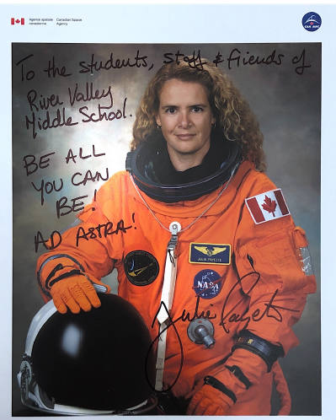
Science Week 8 - International Space Station
Did you know R.V.M.S.’s connection with NASA and the International Space Station?
While visiting N.B. Governor General during the Spring Flood in 2019, Julie Payette made a surprise visit to River Valley and spoke to students about the importance of believing in yourself and to “Be All You Can Be”. Before becoming Canada’s 29th Governor General 2017 Ms. Payette flew on Space Shuttle Discovery and was the first Canadian to participate in an ISS assembly mission and to board the Space Station.
Payette also served as the flight engineer aboard Space Shuttle Endeavour on the 29th Shuttle mission to the International Space Station.

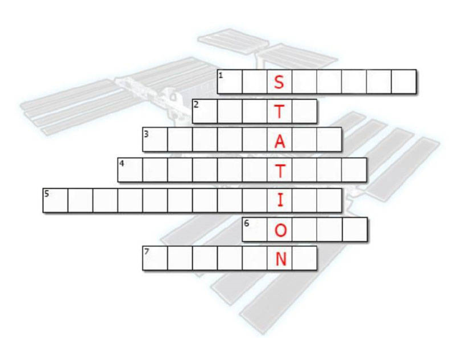
Activity 1- Check out this article from NASA Knows about the International Space Station after you have read it try to solve “What is the International Space Station” Word Puzzle
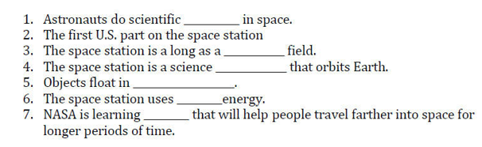

Activity 2 – Need help finding the I.S.S.:
- What to Look For in the sky
The Space Station looks like an airplane or a very bright star moving across the sky, except it doesn’t have flashing lights of change direction. It will also be moving faster than a typical airplane at about 17 500 miles per hour. How to locate it in the sky
- Sighting Locations-Use the link to find the exact day and time you can see the ISS fly by your location.
Activity 3- Take a Virtual Tour of The International Space Station (I.S.S.)
Join Expedition 33 Commander Suni Williams as she gives a tour of the ISS and some of the different modules and explains how astronauts exercise in space.
Activity 4- Simulator-Docking at the I.S.S.
Be an Astronaut- This simulator will put you in the driver’s seat with the controls of the actual interface used by NASA Astronauts to manually pilot Space X Dragon 2 vehicle to the International Space Station.
Activity 5- Reflection
If you had an opportunity to travel to the International Space Station would you go? Explain why or why not.

